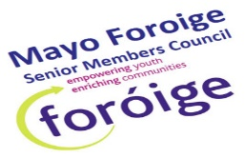

Personal Details:
Senior Members Council
Application Form

No
Are you currently a member of Foróige’s Reference Panel? Yes
No
Yes
Have you participated on the council previously?
Name of Foróige club you are a member of:
How long have you been a member?
(mobile)

Email (Block Capitals)
Date of Birth: / /

Tel:
(home)
Address:
Female
Sex: Male
Name:

Leadership Qualities:
Why would you like the opportunity to participate on the senior members council?

Tell us of your experience of sitting on a committee? If not, what would you like to achieve?

Please give an example of how you demonstrated effective leadership in your club?

The senior members council will meet once a month, please tell us how committed you are in attending these meetings?

Signed Date:

(Participant)
Parent/Guardian Consent:

I give permission for the above named to attend the Mayo Foróige Senior members council meetings and events.

Signed: Date:
(Parent/Guardian)

Leader Recommendation for senior members council:

I recommend from Foróige club because

Signed by Leader:

